AI Resume Builder
Internship Project Documentation

Project Title: AI Resume Builder
Internship Company: Majecurious
Mentor Name: Shiyal Sanjay Sir
Faculty Guide: Anil Gujariya
College & Semester: Gyanmanjari Education Mahua – Sem 6th
Live Demo: https://ai-resume-bolt.netlify.app
Submission Date: 25 April, 2026

Acknowledgement
I would like to express my sincere gratitude to my mentor, Shiyal Sanjay Sir, for his valuable guidance and support throughout the internship project.
I also thank Majecurious for providing the opportunity to work on a real-world full stack project.
I am grateful to Anil Gujariya Sir for continuous academic support and encouragement during the development of this project.
This project helped in understanding practical implementation of frontend development, backend integration, database management, and AI-powered applications.

Abstract
AI Resume Builder is a full stack web application developed to help students and freshers create professional and ATS-friendly resumes using Artificial Intelligence.
The application allows users to enter their details in a single prompt-based input system, after which AI processes the information and generates structured resume content automatically.
The project is developed using React for frontend development, Node.js and Express for backend services, Supabase for database management and authentication, and Google Gemini API for AI-powered resume generation.
Users can edit generated resume sections, select resume templates, preview the final output, and download resumes in PDF format.
The system provides a simple and beginner-friendly workflow for creating resumes quickly and efficiently.

Table of Contents
1. Introduction
2. Problem Statement
3. Objectives
4. Scope of the Project
5. Technology Stack
6. System Flow
7. System Architecture
8. Features
9. UI Screens
10. Database Design
11. API Overview
12. AI Integration
13. Project Implementation
14. Testing
15. Challenges Faced
16. Deployment
17. Future Enhancements
18. Conclusion

1. Introduction
AI Resume Builder is a web-based application designed for students, freshers, and internship seekers who need professional resumes quickly and efficiently.
Many users face difficulty in creating proper resume structures and writing professional descriptions.
This project simplifies the resume creation process using AI-powered content generation and an easy-to-use interface.

2. Problem Statement
• Freshers often lack knowledge about professional resume writing.
• Many users are unfamiliar with ATS-friendly resume structures.
• Writing resume summaries and experience descriptions is difficult for beginners.
• Manual resume creation is time-consuming and confusing.

3. Objectives
• Build a full stack AI-powered resume builder.
• Generate structured resumes using AI.
• Provide editable resume sections.
• Allow PDF download functionality.
• Learn frontend, backend, database, and AI integration concepts.

4. Scope of the Project
In Scope:
• AI-based resume generation
• Resume editing
• Resume preview
• PDF download
• Authentication system
Out of Scope:
• Public resume sharing
• Payment integration
• Advanced analytics
• Multi-language resume generation

5. Technology Stack

Frontend:
• React.js
• Tailwind CSS
Backend:
• Node.js
• Express.js
Database & Authentication:
• Supabase
AI Integration:
• Google Gemini API
Deployment:
• Netlify
• Render

6. System Flow
1. User opens the application.
2. User signs up or logs in.
3. User creates a new resume.
4. User enters complete resume details in a single prompt.
5. AI processes the prompt and generates structured resume content.
6. User edits generated content if needed.
7. User previews the resume.
8. User downloads the final resume as PDF.

7. System Architecture

Frontend (React Application)
↓
Supabase Authentication & Database
↓
Node.js + Express AI Server
↓
Google Gemini API

8. Features
• User authentication using Supabase Auth
• AI-powered resume generation
• Editable resume sections
• Multiple resume templates
• Responsive UI design
• Resume preview functionality
• PDF download support

9. UI Screens
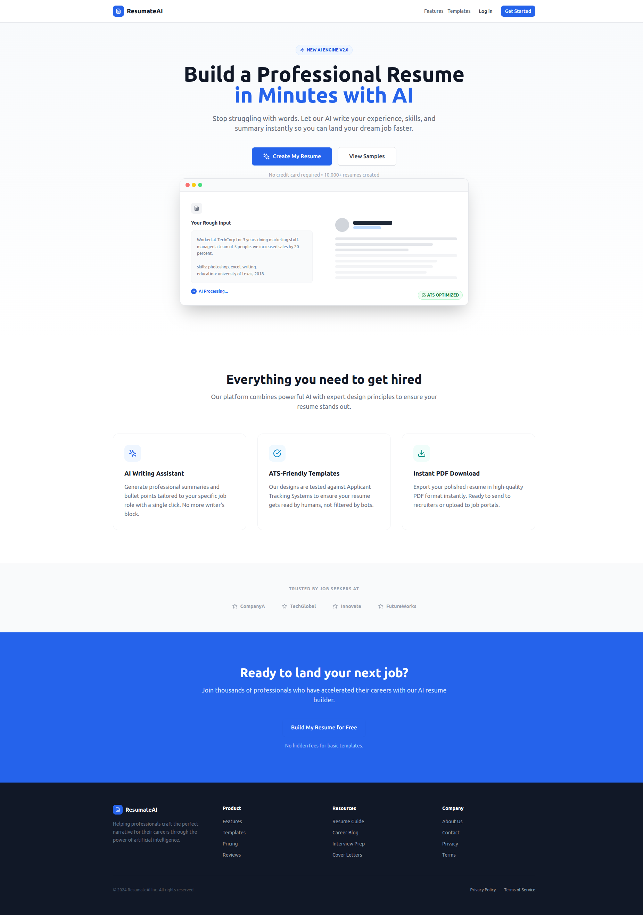
The following UI screens are included in the project:
• Landing Page
• Sample Resume Themes Page
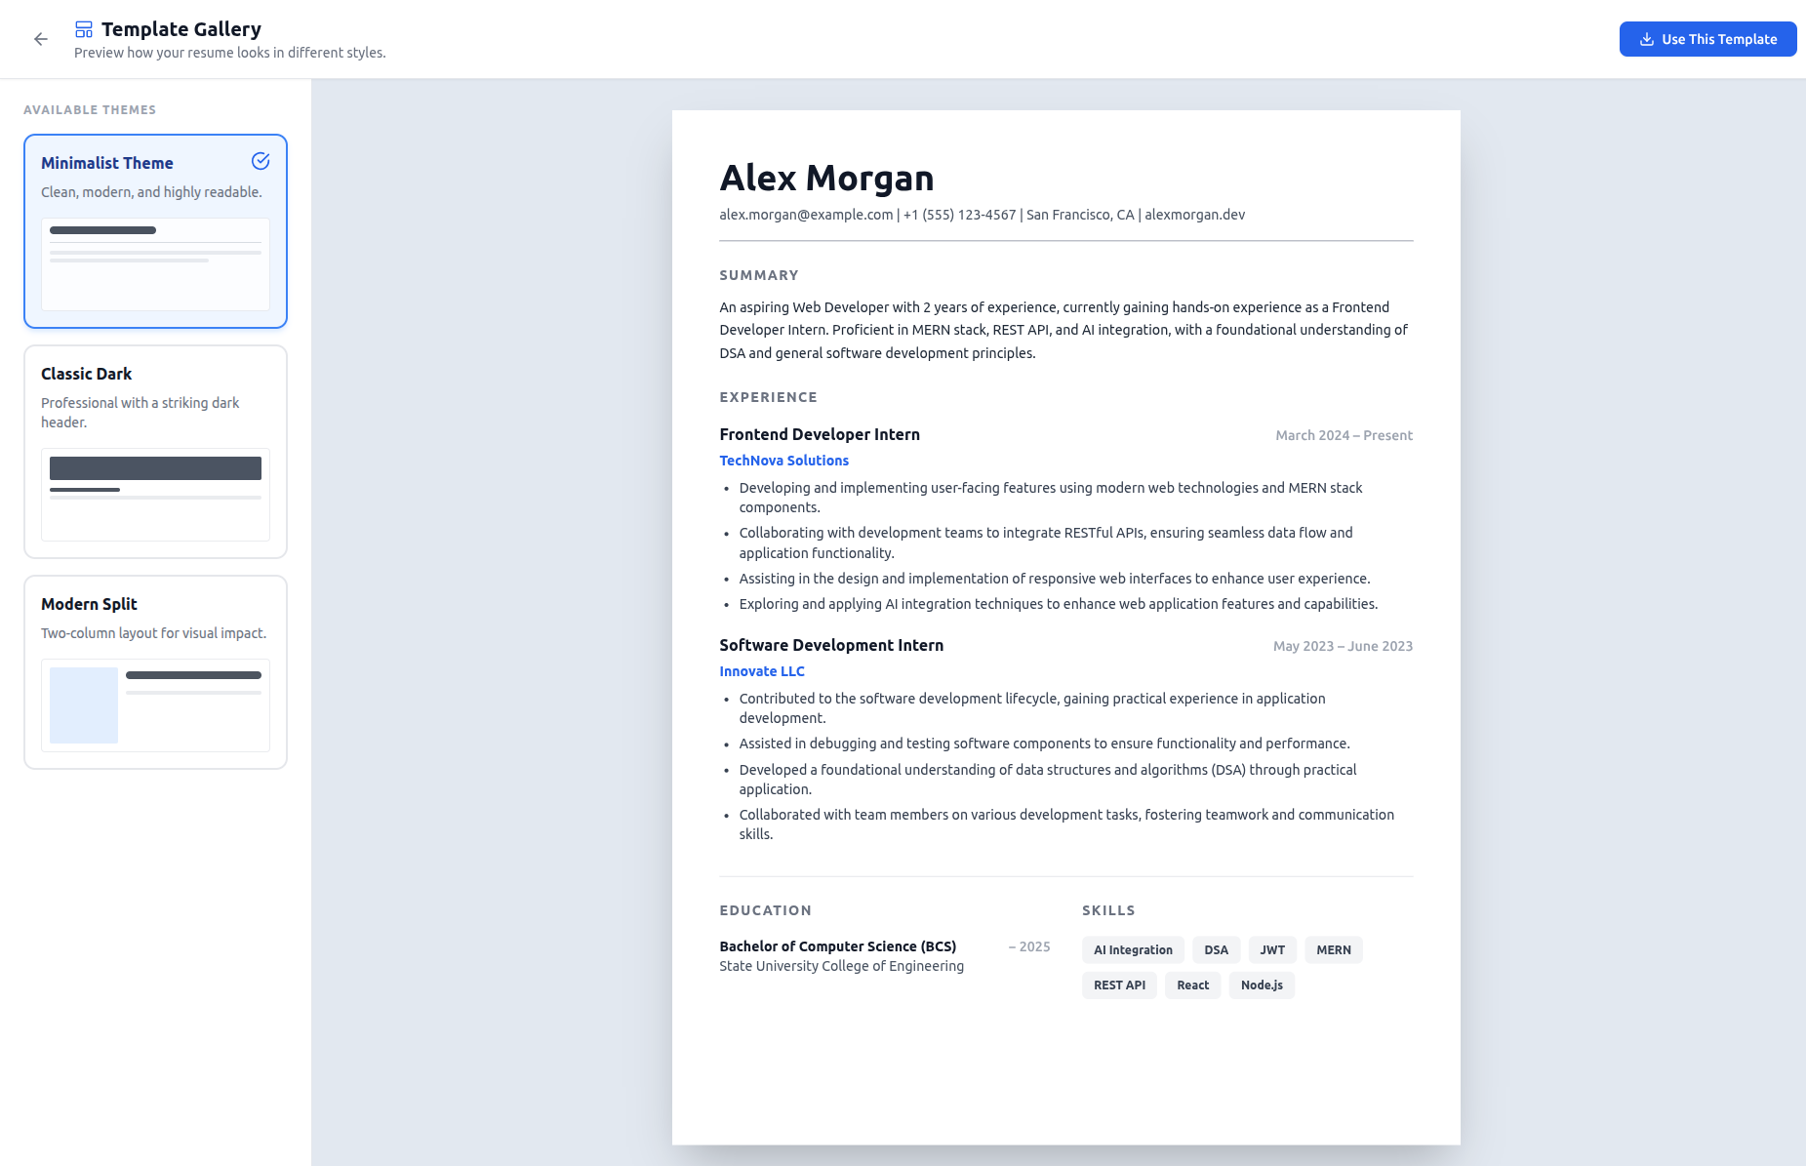

• Dashboard Page
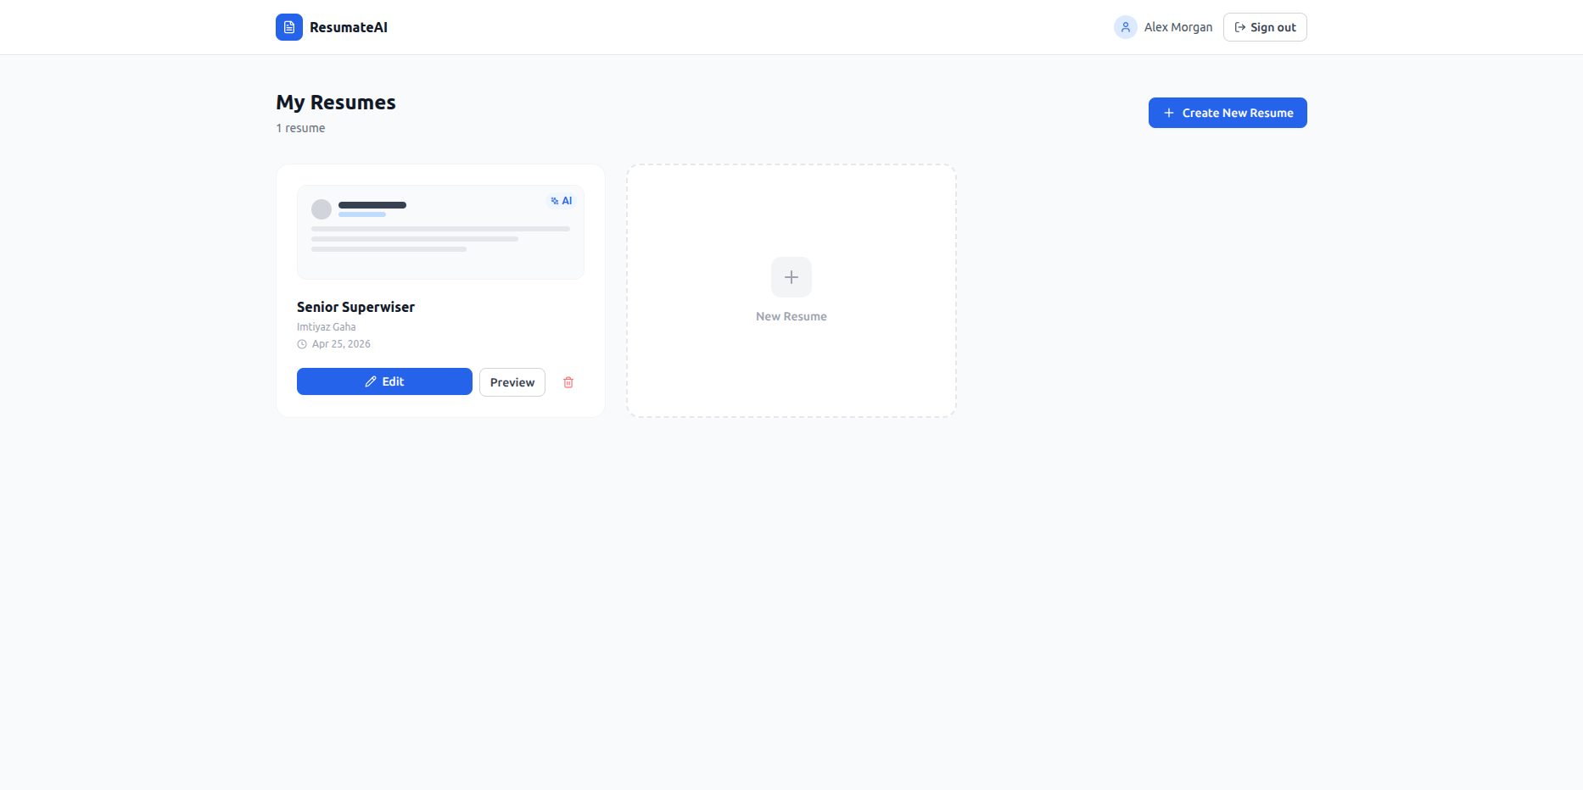
• Resume Create Page
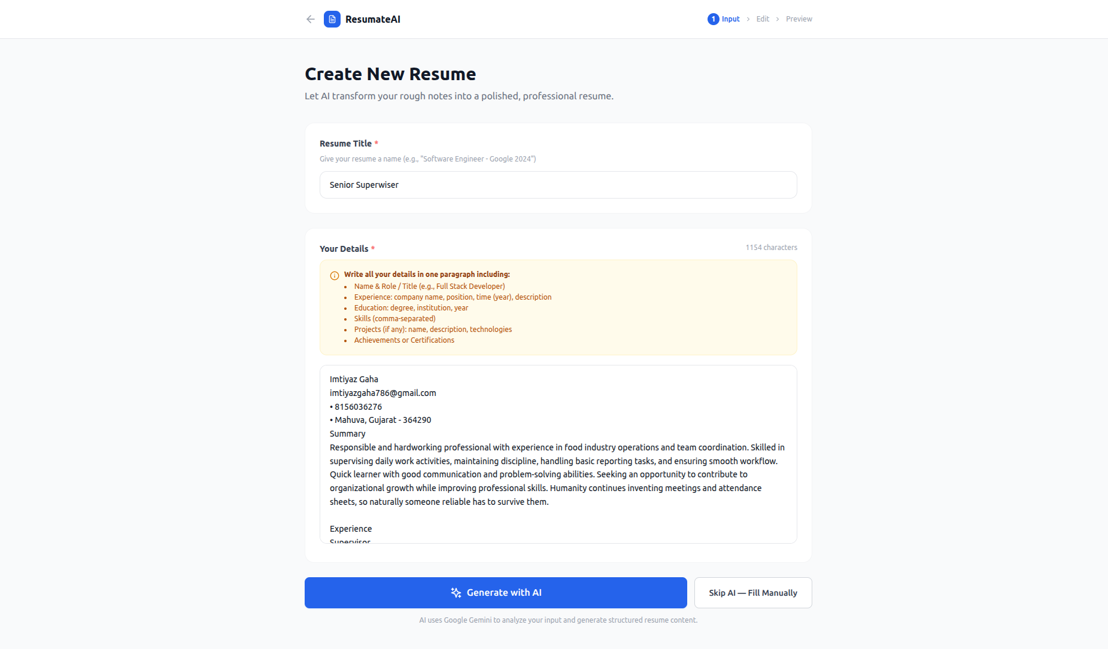

• Resume Edit Page
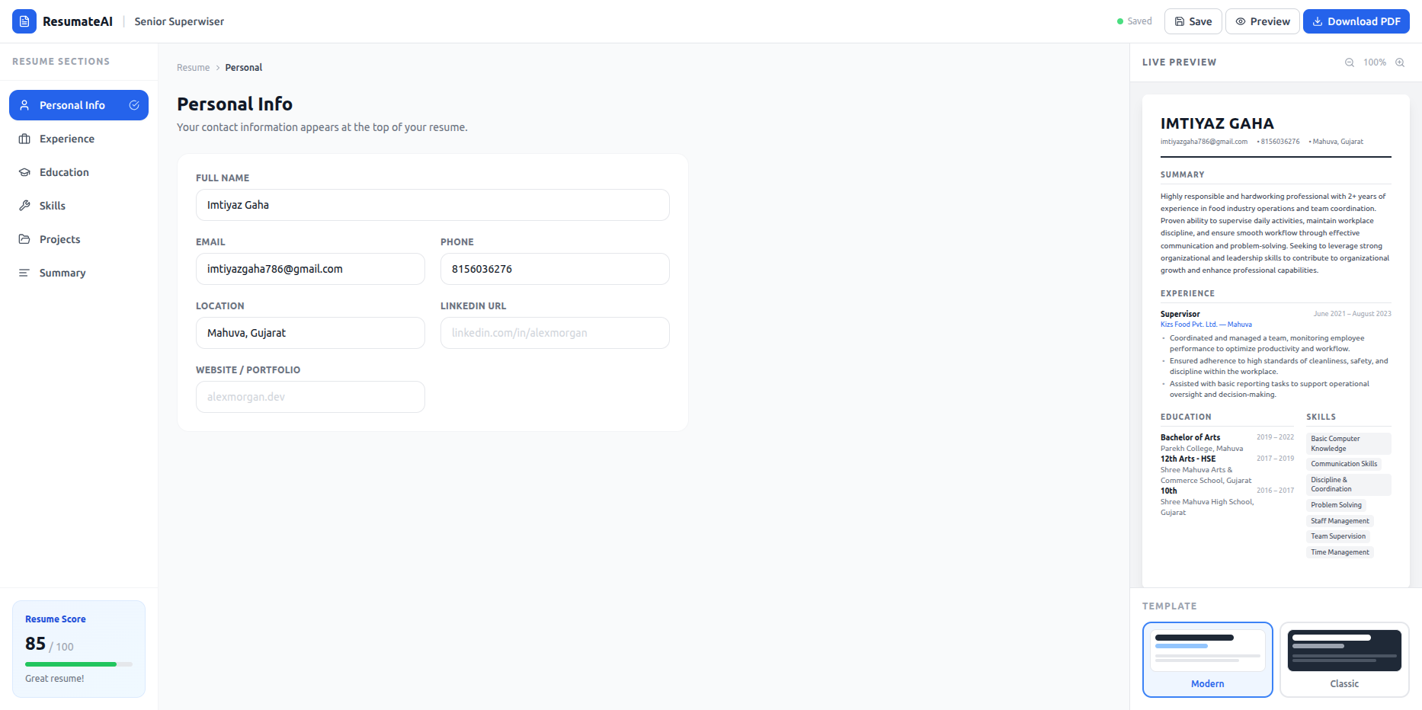
• Resume Preview Page
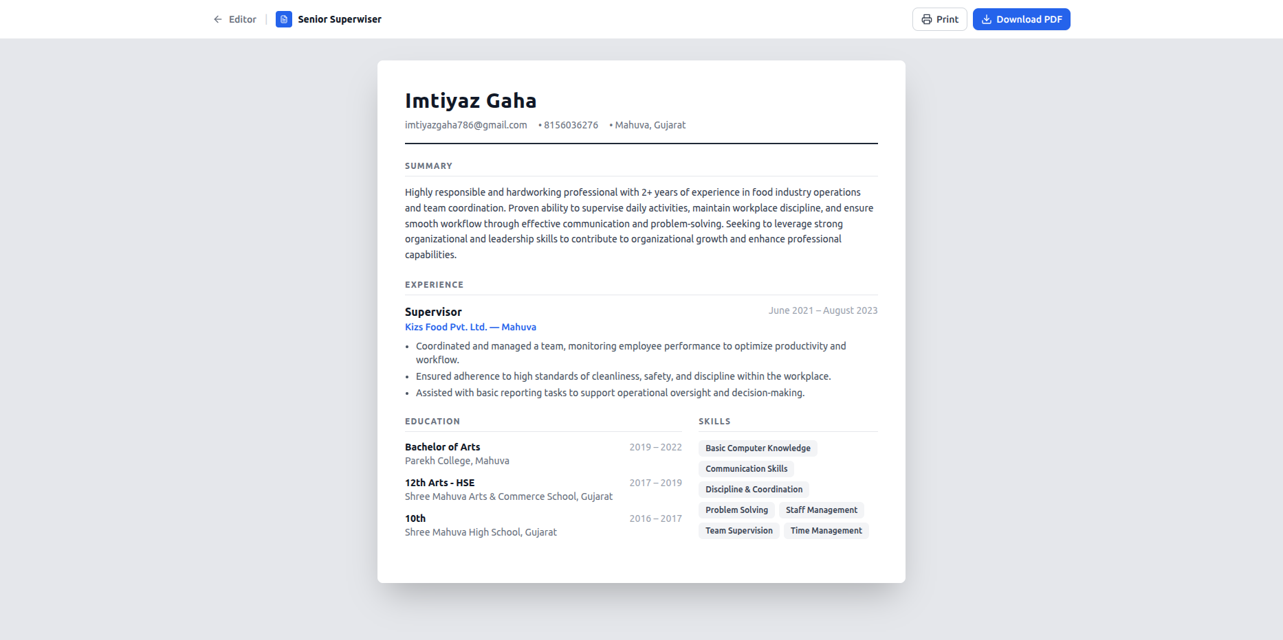

10. Database Design
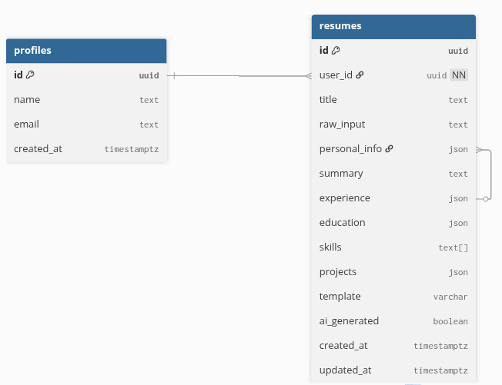

11. API Overview
Authentication:
• Supabase Authentication is used directly for Login and Signup.
AI Resume Parsing API:
POST:
https://ai-resume-builder-16vp.onrender.com/parse-resume
Purpose:
• Accept raw resume input
• Process data using Google Gemini API
• Return structured resume content
Resume CRUD:
• Resume CRUD operations are handled directly using Supabase client library in frontend.

12. AI Integration
Google Gemini API is used for generating professional resume content.
The user enters complete resume details in a single prompt.
The backend server processes the prompt and sends it to Gemini API.
The AI response is then converted into structured resume sections such as summary, skills, education, and experience.

13. Project Implementation
• Frontend UI developed using React and Tailwind CSS.
• Authentication integrated using Supabase Auth.
• Resume data stored in Supabase database.
• AI processing handled using Express backend server.
• PDF download functionality added for exporting resumes.

14. Testing
The project was tested manually by performing live usage testing.
Testing Included:
• Authentication flow testing
• Resume generation testing
• Responsive UI testing
• PDF generation testing
• CRUD operation testing

15. Challenges Faced
• Formatting AI-generated responses properly
• Managing responsive layouts for mobile screens
• PDF export formatting
• Handling structured resume data from a single prompt input

16. Deployment

Frontend Hosting:
• Netlify
Database & Authentication:
• Supabase
Backend Server:
• Render
Live Demo:
https://ai-resume-bolt.netlify.app

17. Future Enhancements
• More resume templates
• Resume score analysis
• Cover letter generation
• Export in multiple formats

18. Conclusion
The AI Resume Builder project successfully provides a simple and efficient way for users to create professional resumes using Artificial Intelligence.
The project helped in understanding full stack development concepts including frontend development, backend APIs, database management, authentication, and AI integration.

__________________________
* * *

